Naan Mudhalvan - Artificial Intelligence - Group1

Earthquake Prediction Model Using Python

Introduction:

This project aims to predict the magnitude and probability of Earthquake occurring in a particular region using the historic data.

Earthquakes are natural disasters that can cause significant destruction and loss of life. Predicting when and where earthquakes may occur is a challenging task, but it is of utmost importance for early warning systems and disaster preparedness. In recent years, advancements in artificial intelligence and data analysis have opened up new possibilities for creating predictive models for earthquakes.

An earthquake prediction model using Python in artificial intelligence is a powerful application that harnesses data science and machine learning techniques to make predictions about earthquakes.

Significance:

An earthquake prediction model using Python and artificial intelligence holds significant promise for disaster mitigation and public safety. By leveraging the power of data and advanced algorithms, this model can provide valuable insights into earthquake patterns, potentially allowing for early warnings and improved disaster preparedness.

Steps to follow:
- Import Libraries:
- Start by importing the necessary libraries.
import numpyas npimportpandasas pd
importmatplotlib.pyplotasplt

import osprint(os.listdir("../input"))
data=pd.read_csv("../input/database.csv")data.head()
data.columns
data=data[['Date','Time','Latitude','Longitude','Depth','Magnitude']]data.head()
.
import numpyas npimportpandasas pd
importmatplotlib.pyplotasplt

import osprint(os.listdir("../input"))
data=pd.read_csv("../input/database.csv")data.head()
data.columns
data=data[['Date','Time','Latitude','Longitude','Depth','Magnitude']]data.head()

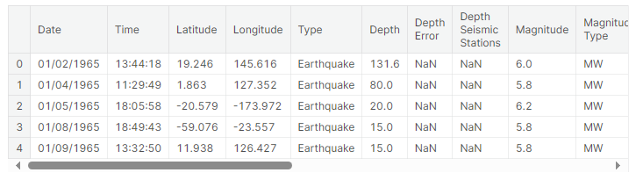data.columns

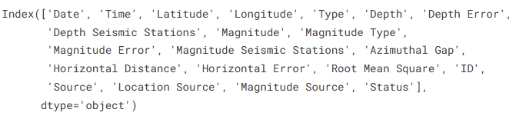

data=data[['Date','Time','Latitude','Longitude','Depth','Magnitude']]
data.head()

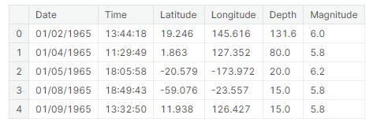
import datetime
import time
timestamp = []
for d, t in zip(data['Date'], data['Time']):try:
ts= datetime.datetime.strptime(d+' '+t, '%m/%d/%Y %H:%M:%S')timestamp.append(time.mktime(ts.timetuple()))timestamp.append('ValueError')
timeStamp= pd.Series(timestamp)
data['Timestamp']=timeStamp.values

2. Data Preparation:
- Using Pandas, you read seismic data from a CSV file.
- You handle date time parsing issues and extract specified columns (such as "Timestamp", "Latitude", "Longitude", "Magnitude", and "Depth").
- Rows with "Value Error" in the "Time stamp" column are remove.

final_data=data.drop(['Date','Time'],axis=1)
final_data=final_data[final_data.Timestamp!='ValueError']
final_data.head()

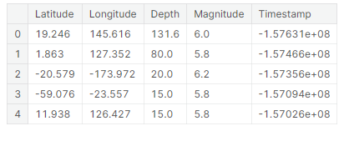
frommpl_toolkits.basemapimportBasemap

m=Basemap(projection='mill',llcrnrlat=-80,urcrnrlat=80,llcrnrlon=-180,urcrnrlon=180,lat_ts=20,resolution='c')

longitudes=data["Longitude"].tolist()
latitudes=data["Latitude"].tolist()
#m = Basemap(width=12000000,height=9000000,projection='lcc',
#resolution=None,lat_1=80.,lat_2=55,lat_0=80,lon_0=-107.)
x,y=m(longitudes,latitudes)

fig=plt.figure(figsize=(12,10))
plt.title("All affected areas")
m.plot(x,y,"o",markersize=2,color='blue')
m.drawcoastlines()
m.fillcontinents(color='coral',lake_color='aqua')
m.drawmapboundary()
m.drawcountries()
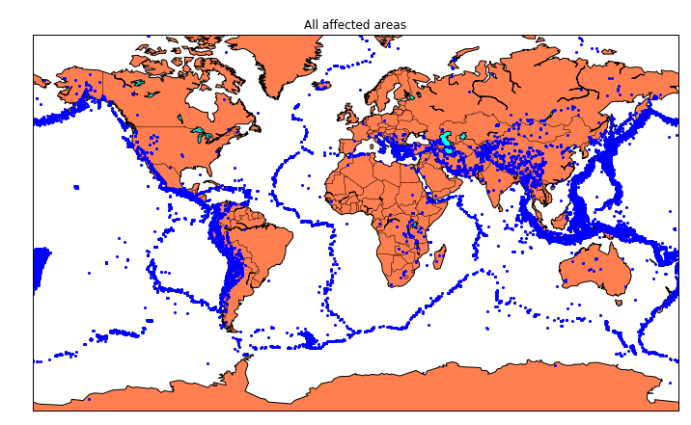
plt.show()

x,y= m(longitudes,latitudes)
fig=plt.figure(figsize=(12,10))plt.title("All affected areas")
m.plot(x, y, "o", markersize= 2, color = 'blue')m.drawcoastlines()m.fillcontinents(color='coral',lake_color='aqua')m.drawmapboundary()
m.drawcountries()plt.show()
timeStamp= pd.Series(timestamp)data['Timestamp']=timeStamp.value
final_data= data.drop(['Date', 'Time'], axis=1)
final_data= final_data[final_data.Timestamp!= 'ValueError']final_data.head

3. Data Visualization:
  - To visualize earthquake locations on a map, construct a Base map.
frommpl_toolkits.basemapimportBasemap

m=Basemap(projection='mill',llcrnrlat=-80,urcrnrlat=80,llcrnrlon=-180,urcrnrlon=180,lat_ts=20,resolution='c')

longitudes = data["Longitude"].tolist()latitudes=data["Latitude"].tolist()

x,y= m(longitudes,latitudes)
fig = plt.figure(figsize=(12,10))plt.title("All affected areas")
m.plot(x, y, "o", markersize= 2, color = 'blue')m.drawcoastlines()m.fillcontinents(color='coral',lake_color='aqua')m.drawmapboundary()
m.drawcountries()plt.show()

fromsklearn.ensembleimportRandomForestRegressor

reg=RandomForestRegressor(random_state=42)
reg.fit(X_train,y_train)
reg.predict(X_test)

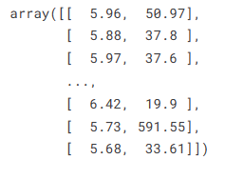

Data Splitting:

- Using train_test_split, divide the data into training and testing sets.
- You train a Random Forest Regress or using the training set of data.
- The score() method is used to assess the model.

fromkeras.modelsimportSequential
fromkeras.layersimportDense

defcreate_model(neurons,activation,optimizer,loss):
model=Sequential()
model.add(Dense(neurons,activation=activation,input_shape=(3,)))
model.add(Dense(neurons,activation=activation))
model.add(Dense(2,activation='softmax'))

model.compile(optimizer=optimizer,loss=loss,metrics=['accuracy'])

returnmodel

fromkeras.wrappers.scikit_learnimportKerasClassifier

model=KerasClassifier(build_fn=create_model,verbose=0)

# neurons = [16, 64, 128, 256]
neurons=[16]
# batch_size = [10, 20, 50, 100]
batch_size=[10]
epochs=[10]
# activation = ['relu', 'tanh', 'sigmoid', 'hard_sigmoid', 'linear', 'exponential']
activation=['sigmoid','relu']
# optimizer = ['SGD', 'RMSprop', 'Adagrad', 'Adadelta', 'Adam', 'Adamax', 'Nadam']
optimizer=['SGD','Adadelta']
loss=['squared_hinge']

param_grid=dict(neurons=neurons,batch_size=batch_size,epochs=epochs,activation=activation,optimizer=optimizer,loss=loss)

Hyper parameter Tuning (Grid Search):
- Grid Search CV is used to adjust the hyper parameters of the Random Forest Regressor.

grid=GridSearchCV(estimator=model,param_grid=param_grid,n_jobs=-1)
grid_result=grid.fit(X_train,y_train)

print("Best: %f using %s"%(grid_result.best_score_,grid_result.best_params_))
means=grid_result.cv_results_['mean_test_score']
stds=grid_result.cv_results_['std_test_score']
params=grid_result.cv_results_['params']
formean,stdev,paraminzip(means,stds,params):
print("%f (%f) with: %r"%(mean,stdev,param))

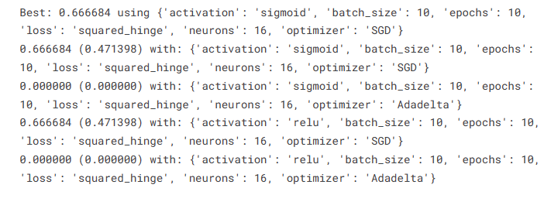
model=Sequential()
model.add(Dense(16,activation='relu',input_shape=(3,)))
model.add(Dense(16,activation='relu'))
model.add(Dense(2,activation='softmax'))

model.compile(optimizer='SGD',loss='squared_hinge',metrics=['accuracy'])

model.fit(X_train,y_train,batch_size=10,epochs=20,verbose=1,validation_data=(X_test,y_test))

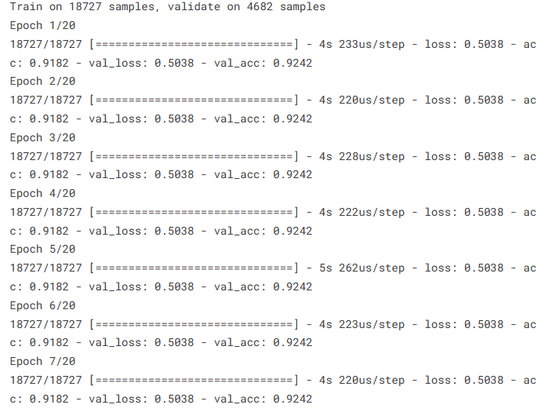
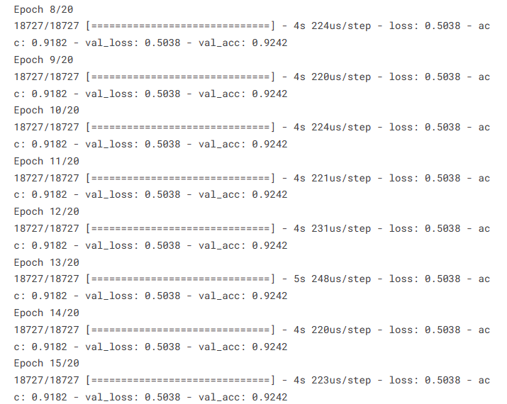
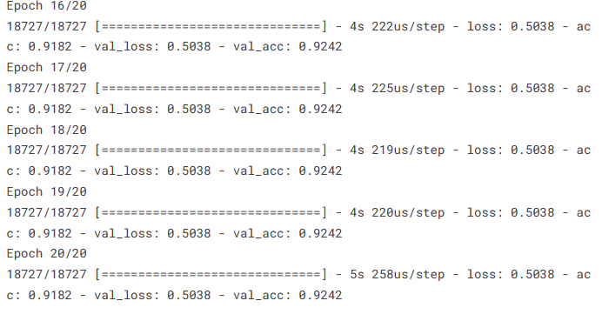

Neural Network (Keras):
- You build an earthquake prediction Keras neural network model.
- To tune hyper parameters, you define a parameter grid.
- Grid Search CV is used to adjust the neural network's hyper parameters.

model.add(Dense(neurons,activation=activation,input_shape=(3,)))model.add(Dense(neurons, activation=activation))model.add(Dense(2,activation='softmax'))
model.compile(optimizer=optimizer,loss=loss,metrics=['accuracy'])returnmodel
fromkeras.wrappers.scikit_learnimportKerasClassifier

model=KerasClassifier(build_fn=create_model,verbose=0)neurons=[16]
batch_size=[10]
epochs=[10]
activation=['sigmoid','relu']optimizer = ['SGD', 'Adadelta']loss=['squared_hinge']
param_grid=dict(neurons=neurons,batch_size=batch_size,epochs=epochs,activation=activation,optimizer=optimizer,loss=loss)
fromkeras.modelsimportSequentialfromkeras.layersimportDense

defcreate_model(neurons,activation,optimizer,loss):model=Sequential()

Model Evaluation:
- You use the training data to create the final neural network model.
- Using the test data, you evaluate the model.
- The trained neural network model is saved to a file called "earthquake.h5" in step eight.
- It appears that you are now asking for changes to the code and a suitable CSV file. Here are a few ideas:

Data Quality:
- Ensure that your seismic data are of high quality. The performance of the model depends on it.

Feature Engineering:

- Investigate and develop fresh characteristics that could raise prediction precision.
grid=GridSearchCV(estimator=model,param_grid=param_grid,n_jobs=-1)grid_result=grid.fit(X_train,y_train)

print("Best:%fusing%s"%(grid_result.best_score_,grid_result.best_params_))means=grid_result.cv_results_['mean_test_score']
stds= grid_result.cv_results_['std_test_score']params=grid_result.cv_results_['params']
for mean, stdev, param in zip(means, stds, params):print("%f(%f)with:%r"%(mean, stdev,param))

Hyper parameter Tuning:
- To identify the ideal model configuration, experiment with various hyper parameters for both the neural network and the Random Forest Regressor.

Data Scaling:
- Scaling or normalizing your input features is something to think about, especially if you' reutilizing neural networks.

Cross-Validation:
- Use cross-validation to evaluate the stability of the model and decrease over fitting.

Model Evaluation Metrics:
- To evaluate the performance of a model, use appropriate evaluation metrics for regression tasks, such as Mean Absolute Error (MAE) or Mean Squared Error (MSE).
model = Sequential()
model.add(Dense(16, activation='relu', input_shape=(3,)))model.add(Dense(16,activation='relu'))model.add(Dense(2, activation='softmax'))

model.compile(optimizer='SGD', loss='squared_hinge', metrics=['accuracy'])
model.fit(X_train, y_train, batch_size=10, epochs=20, verbose=1, validation_data=(X_test, y_test))

Data Source:
- Check that the earthquake dataset you have access to is reputable and current. On websites like the USGS Earthquake Hazards Program, you can find earthquake datasets.
[test_loss,test_acc]=model.evaluate(X_test,y_test)
print("EvaluationresultonTestData:Loss={},accuracy={}".format(test_loss,test_acc))

File directories:

- Ensure that the file Directories you use to load data and save models are precise and easy to retrieve.

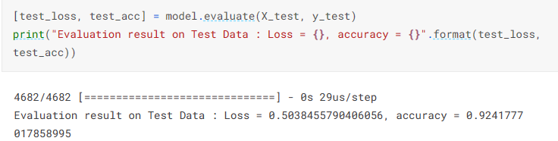

model.save('earthquake.h5')

Challenges:

Creating an accurate earthquake prediction model is not without challenges. Earthquake events are complex and influenced by various factors. While machine learning and deep learning models can provide insights, complete accuracy in earthquake prediction remains an ongoing scientific challenge.

Conclusion:

An earthquake prediction model using Python and artificial intelligence represents a crucial application that showcases the potential of AI and data science in addressing real-world problems. It offers the possibility of saving lives and reducing the impact of natural disasters by providing timely information and insights for decision-makers and the public.

In order to properly build a CSV file for earthquake data, make sure your dataset has necessary columns like "Date", "Time", "Latitude", "Longitude", "Magnitude" and "Depth." You can get reliable sources for earthquake data, such as the USGS Earthquake Hazards Program or others, from these repositories.

This design thinking document provides a structured roadmap for developing an earthquake prediction model, ensuring that each crucial step is addressed systematically. It promotes a data-driven approach and continuous improvement for achieving accurate earthquake magnitude predictions.

